***A Mini Project Synopsis on***

# Leave Management Application

**S.E. - I.T Engineering**

**Submitted By**

**Saniya Dutta Moodle ID: 20104041**

**Shreya Mahajan Moodle ID: 20104001**

**Anish Bhosale Moodle ID: 20104033**

**Kunal Palande Moodle ID: 20104031**

**Under The Guidance Of**

## Prof. Susmita Das



**DEPARTMENT OF INFORMATION TECHNOLOGY**

A.P.SHAH INSTITUTE OF TECHNOLOGY

G.B. Road, Kasarvadavali, Thane (W), Mumbai-400615

UNIVERSITY OF MUMBAI

**Academic year: 2021-22**

# CERTIFICATE

This to certify that the Mini Project report on Leave Management Application has been submitted by Saniya Dutta(20104041), Shreya Mahajan(20104001), Anish Bhosale(20104033), Kunal Palande(20104031) who are Bonafede students of A. P. Shah Institute of Technology, Thane, Mumbai, as a partial fulfilment of the requirement for the degree in **Information Technology**, during the academic year **2021-22** in the satisfactory manner as per the curriculum laid down by University of Mumbai.

Prof. Susmita Das

Guide

|  |  |
| --- | --- |
| Prof. Kiran Deshpande | Dr. Uttam D. Kolekar |
| Head Department of Information Technology | Principal |

External Examiner(s)

1.

2.

Place: A. P. Shah Institute of Technology, Thane. Date:

## TABLE OF CONTENTS

1. Introduction............................................................................................04
   1. Purpose.......................................................................................04
   2. Objectives...................................................................................04
   3. Scope..........................................................................................05
2. Problem Definition…………………..............................................................06
3. Proposed System………............................................................................07
   1. Features and Functionality……………………………..……………………...08
4. Project Outcomes...................................................................................10
5. Software Requirements..........................................................................11
6. Project Design.........................................................................................12
7. Project Scheduling………………..................................................................22

8. Conclusion…………………………………………………………………………………………..24

9. Reference…………………………………………………………………………………………….25

10. Acknowledgement……………………………………………………………………………..26

**Chapter 1**

**Introduction**

In the existing “Leave Record Management System”, every College/Department follows manual procedure in which Faculty enters leave information of student in a record book. At the end of each month/session, Administration Department calculates leaves of every member which is a time-consuming process and there are chances of losing data or errors in the records.

This application is a “Leave Record Management” module that is critical for HR tasks and keeps the record of vital information regarding student information and their leaves. It allows students to request leaves if he/she is eligible in the given criteria. In this system, the students can register themselves and can request leaves by mentioning the reason. Faculty (as an Admin user) can approve or disapprove the leave requests and only after permission students can avail leaves.

This application can be used in a college to reduce processing the work load on leaves. This project's main idea is to develop an online centralized application connected to a student “leaveDb” database which will maintain student registration & leaves. Leave management application will reduce paperwork and maintain record in a more efficient & systematic way. This module will calculate the number of leaves taken, thereby helping to calculate the final attendance of students and also erase the whole data after a span of time.

**1.1. Purpose**

The purpose of Leave Management System is to automate the existing manual system so that valuable data/information can be stored for a longer period with easy accessing and manipulation of the same. The organization can maintain computerized records without redundant entries. Basically, the project describes how to manage the records for good performance and better services for educational institutions and can be extended to similar use cases.

**1.2. Objective**

* To automate the existing leave management process in educational institutes
* To decrease the paperwork and enable the process with efficient, reliable record maintenance by using centralized database, thereby reducing chances of data loss
* To provide for an automated leave management system that allows the Faculty to be aware of leaves by students and access their data easily

**1.3. Scope**

* To assist Faculty in reducing the effort spent on keeping track of student attendances.
* To automate the leave management process and increase the productivity of Faculty by saving their time.
* Our project aims at computerizing various processes of Leave Management System.
* In a computer system a person has to fill various information & number of copies of the forms can be easily generated at one time.
* In a computer system, it is not necessary to create the manifest but we can directly print it, which saves our time.
* It satisfies the user requirements (students) and manages the task at hand.
* Application must be easy to use / operate.
* Have an aesthetic & good user interface.
* Be robust & scalable.

**Chapter 2**

**Problem definition**

The old manual system was suffering from a series of drawbacks. Since the system was to be maintained manually the process of keeping, maintaining and retrieving the information was very tedious and time-consuming. There used to be lots of difficulties in associating any particular transaction with a particular context. If any information was to be found it was required to go through the different registers. There would always be unnecessary consumption of time while entering and retrieving records. One more problem was that it was very difficult to find errors while entering the records. Once the records were entered it was very difficult to update these records.

The reason behind it is that there is a lot of information to be maintained and have to be kept in mind for this reason we have provided features which is partially automated (computerized), actually existing system maintainance is quite tedious as one has to enter same information multiple times.

With the implementation of computerized system, the task of keeping records in an organized manner will be solved. The best outcome of the implementation is that the retrieval of information will be at the click of the mouse. So, the proposed system helps in saving the time in different operations and making information flow quite easy.

**Chapter 3**

**Proposed System**

The aim of the proposed system is to develop a system of improved facilities. The proposed system overcomes all the limitations of the existing system. Also, the system helps to reduce the manual work required on behalf of the “Faculty”. Some of the advantages of the proposed system are that it will help to:

* Minimize manual data entry.
* Minimize time needed for leave processing.
* Provide greater efficiency by updating student information time to time.
* Give better service by keeping student records.
* Intuitively guide users by information associated to the tabs.
* Reduce time required for applying for leave.

**3.1 PROPOSED SYSTEM BLOCK DIAGRAM AND FEATURES**

Leave Management System

Student login

Student Registration

Faculty login

After student login he/she

can view student

information, can submit

Leave and can check

Leave Balance.

After Faculty login,

faculty can view all

student information, can

check approval list and

can approve or decline a

new request

In student registration, a

new student can register

himself by putting his

student id, name, contact

number and password

Student can apply for leave by selecting no. of days

Faculty can

approve or

deny a

new leave

request

After student

registration, student

information gets stored

in database

**Important features are as follows**

* The above block diagram is made to highlight the key components in our project in a hierarchical layout.
* Within the title block there are 3 major subtopics which are Student login, Student registration and Faculty login.
* Below the Student login, the important functions are specified regarding the details of what the student can do after logging in his/her account.
* Below the student, Register page the steps to register are described.
* Below the Faculty page the important functions are specified regarding the details of what the faculty can do after logging in the account.
* In this way the above block diagram mentions the project details efficiently and effectively.

**Chapter 4**

**Features and functionalities**

The system design will give full functionality and offer information about the students and why they are requesting for a leave. It offers a well-defined and aesthetic interface, along with saving the details of each student.

* Reporting & applying for leave in a more comprehensive way.
* User Accounts to control the access and maintain security.
* Simple leave status of each registered student availing leave.
* Robust database back-end.
* Types of leave available according to student requirements.
* Well-designed reports.
* Accuracy in work.
* Easy & fast retrieval of information.
* Decrease the load of the person involve in existing manual system.
* Access of any information individually by the staff (Admin).
* Work becomes very speedy.
* Easy to register.

It will be convenient for institute to maintain the records of the students and will save a lot of effort to maintain the files. The system design being simple and significant will provide all the important details of the students to the Faculty. The faculty can accept or reject the leave request that will automatically be generated in student leave status tab.

**Chapter 5**

**Project Outcomes**

* The students can register themselves by providing their name, contact number, student ID and a strong password.
* The students can “login” using the registered student ID and password.
* The students can request for leaves by selecting a valid reason.
* The faculty can login through the “Admin ID” and password.
* The faculty can check the requests of the students in their profile and can approve or deny it accordingly.
* The faculty can view information of the students like their attendance, requests, contact details, student id, etc.

**Chapter 6**

**Software requirements:**

* FRONT-END: Frontend is made by using Visual Studio Code.



* DATABASE: Backend is made by using SQLite.



**Chapter 7**

**Project Design**

System Design of “Leave Management Application”

In this phase, a logical system is built which fulfils the given requirements. Design phase of software development deals with transforming the client’s requirements into a logically working system. Normally, design is performed in the following two steps:

* **Primary Design Phase**:

In this phase, the system is designed at block level. The blocks are created on the basis of analysis done in the problem identification phase. Different blocks are created for different functions emphasis is put on minimising the information flow between blocks. Thus, all activities which require more interaction are kept in one block.

* **Secondary Design Phase**:

In the secondary phase the detailed design of every block is performed.

The general tasks involved in the design process are the following:

1. Design various blocks for overall system processes.
2. Design smaller, compact and workable modules in each block.
3. Design various database structures.
4. Specify details of programs to achieve desired functionality.
5. Design the form of inputs, and outputs of the system.
6. Perform documentation of the design.
7. System reviews.

**HOME PAGE for LEAVE MANAGEMENT APPLICATION**

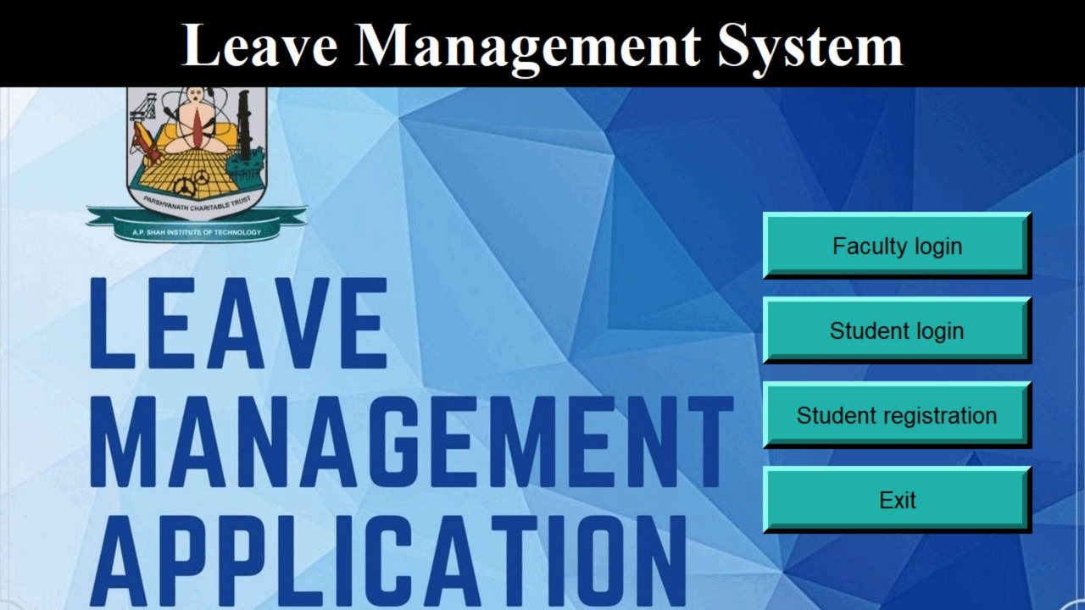

**STUDENT PAGES in LEAVE MANAGEMENT APPLICATION**

**STUDENT LOGIN PAGE**

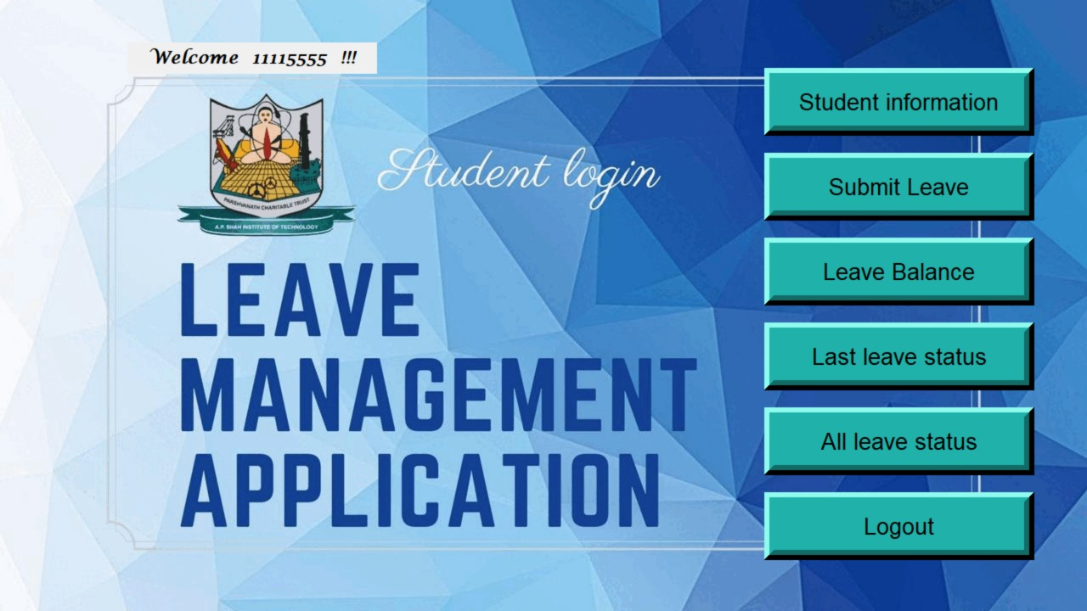

**STUDENT REGISTRATION PAGE**

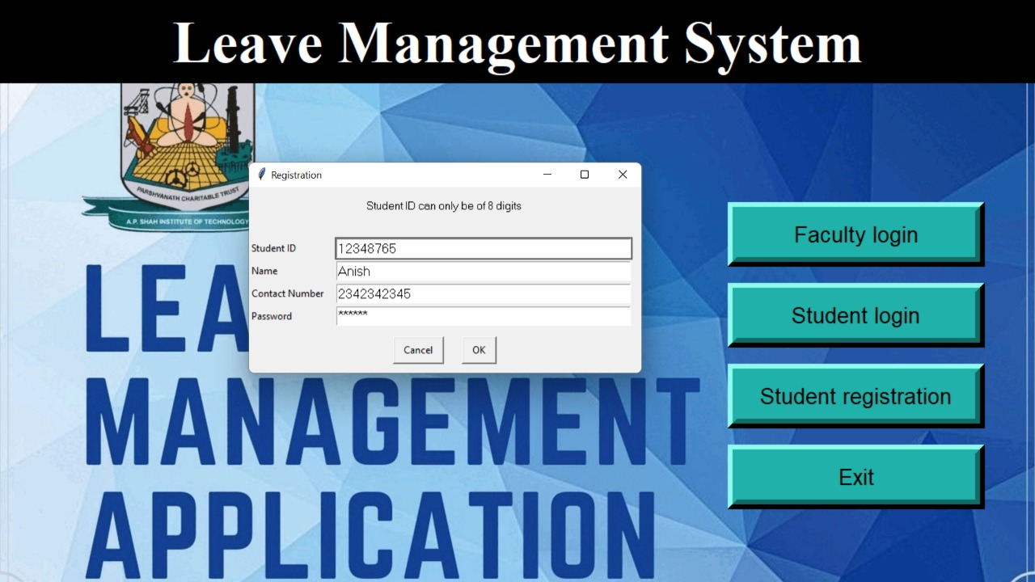

**UTILITY PAGES for STUDENTS**

* **STUDENT LOGIN WINDOW**

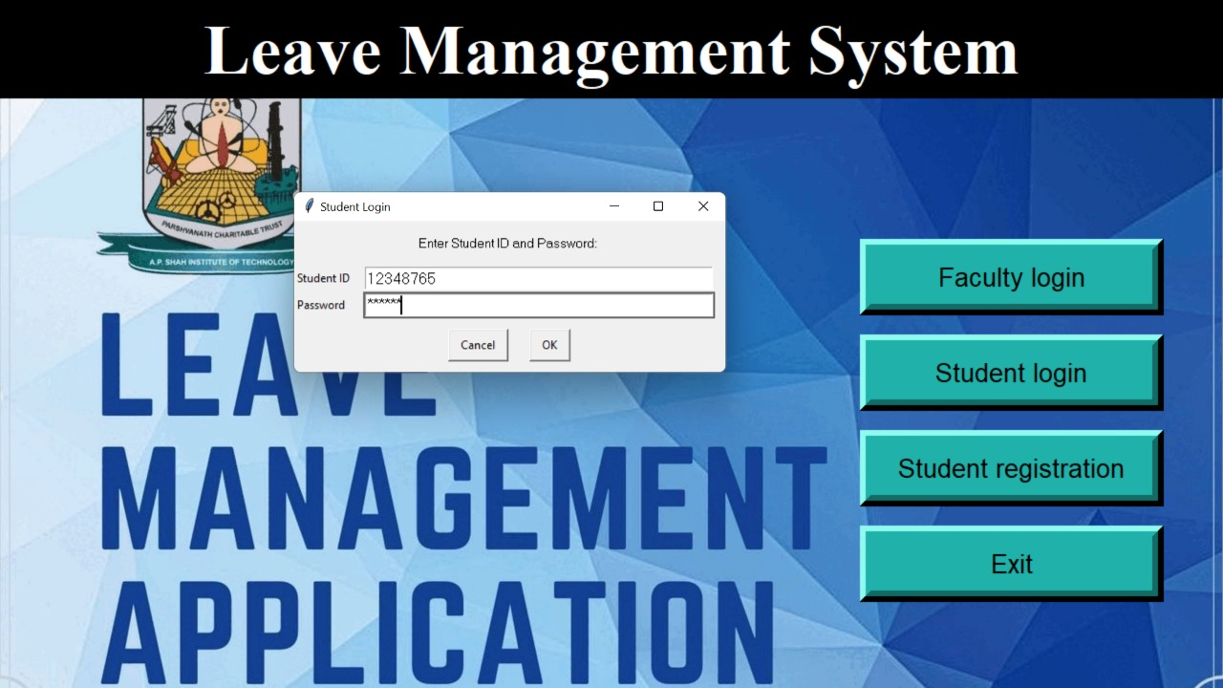

* **STUDENT: STUDENT INFORMATION**

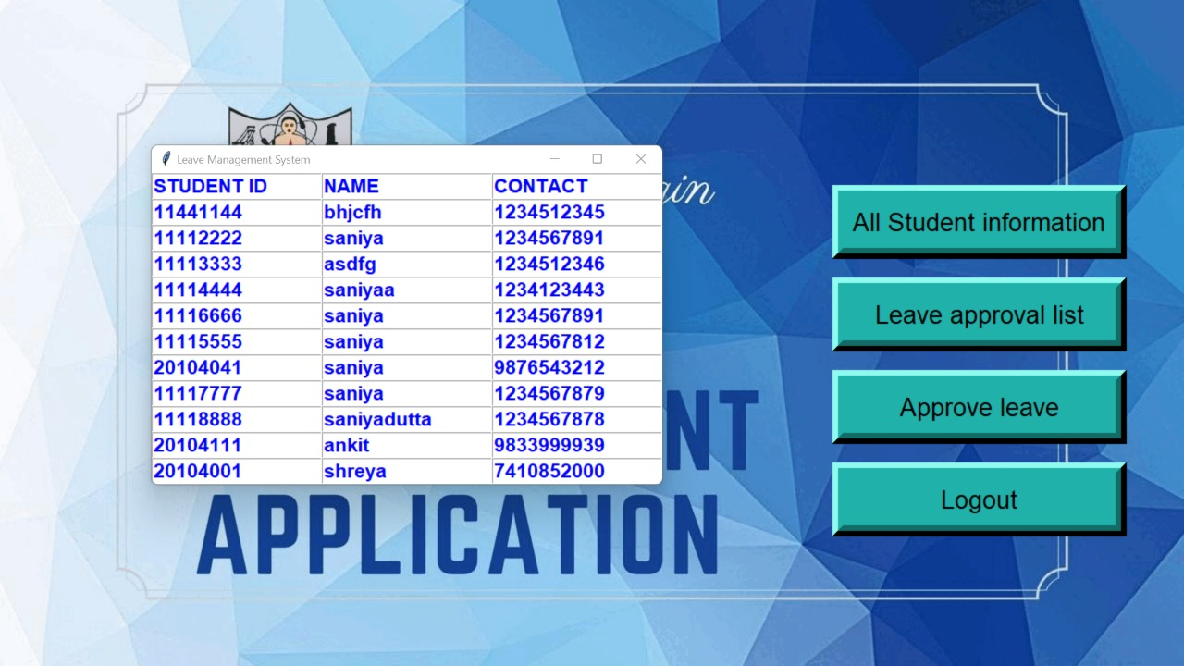

* **STUDENT: SUBMIT LEAVE**

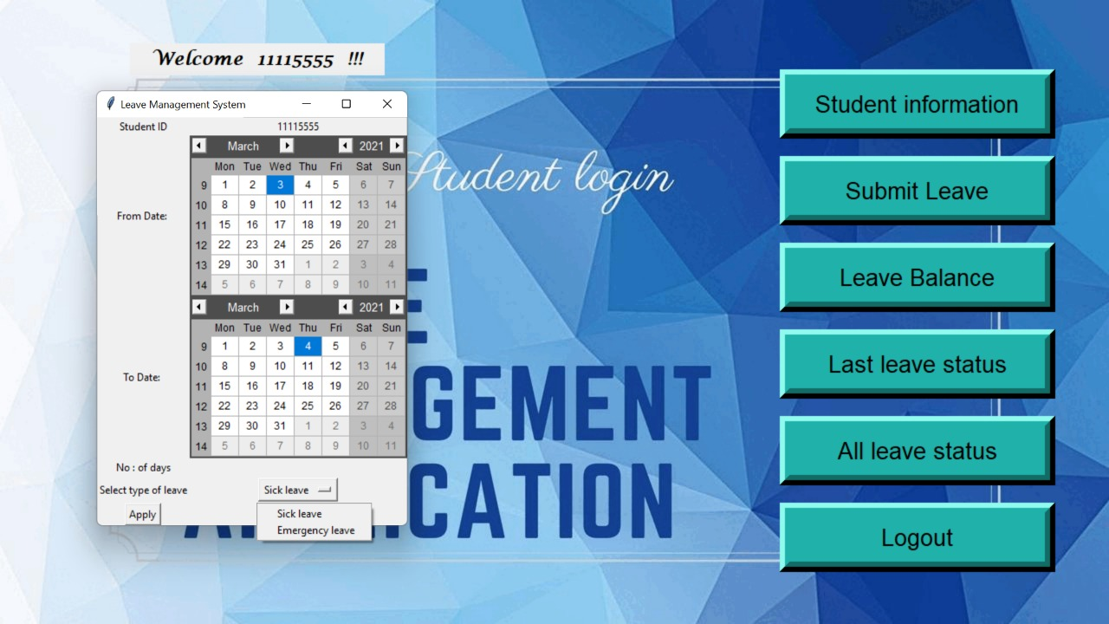

* **LEAVE APPROVAL LIST AS SANCTIONED BY FACULTY THAT CAN BE VIEWED BY STUDENTS**

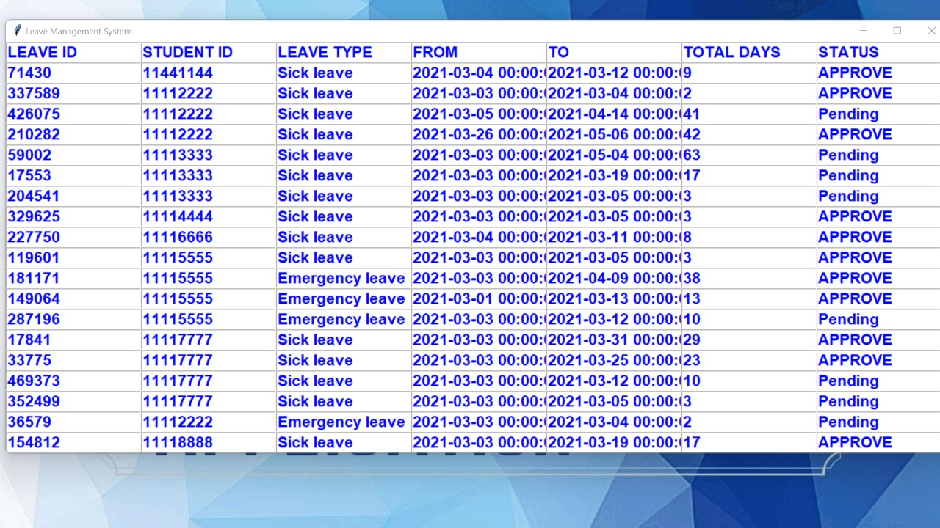

* **STUDENT: LEAVE BALANCE**

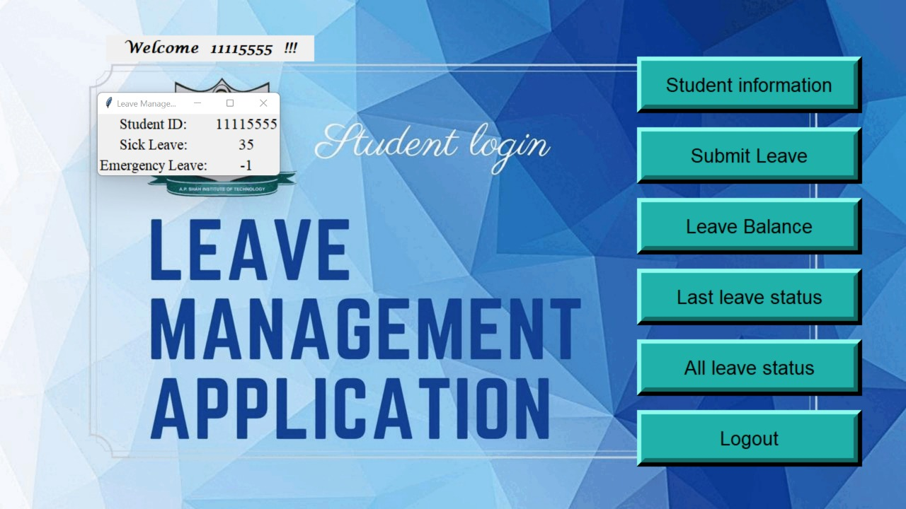

* **STUDENT: LAST LEAVE STATUS**

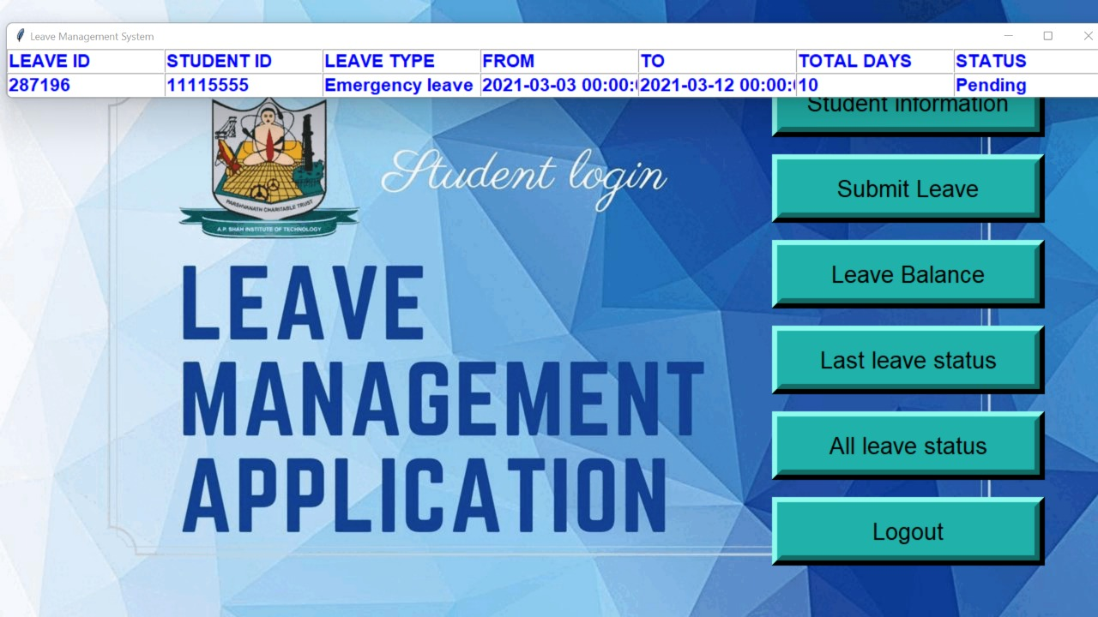

* **STUDENT: ALL LEAVE STATUS**

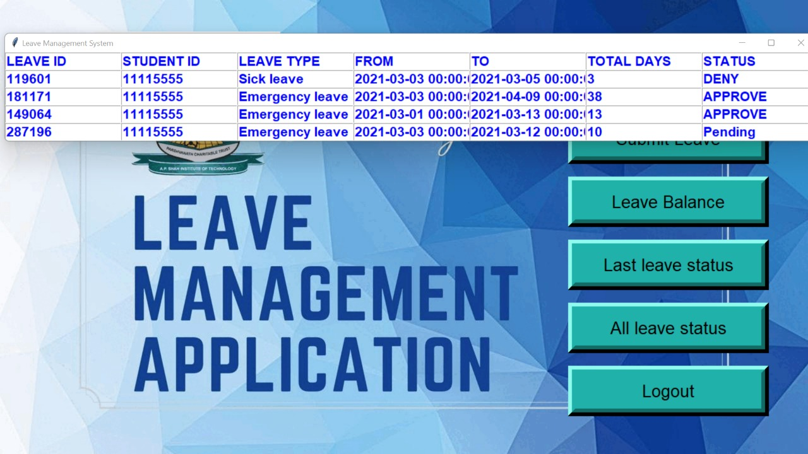

**FACULTY PAGES in LEAVE MANAGEMENT APPLICATION**

**FACULTY LOGIN PAGE**

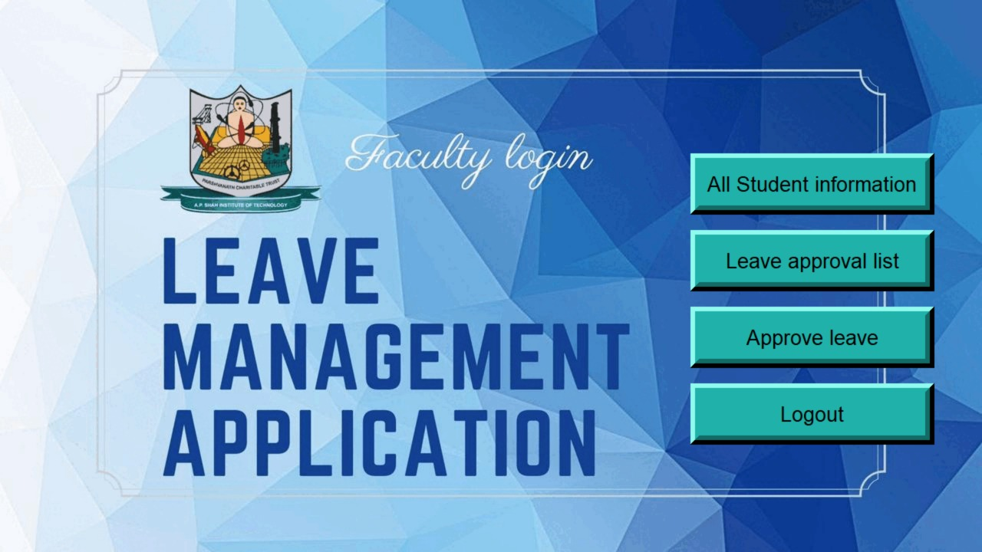

**FACULTY LOGIN WINDOW**

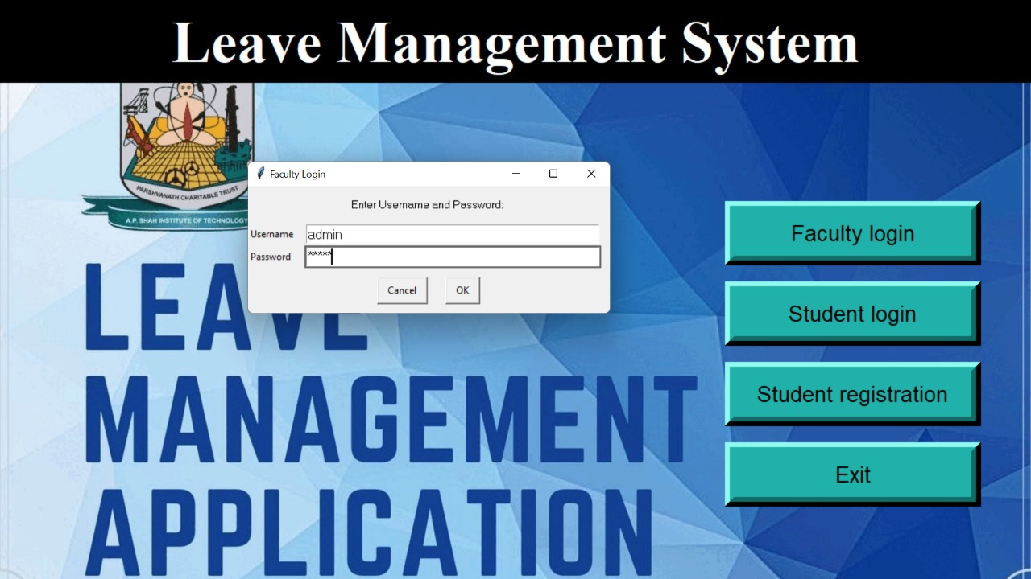

**LEAVE APPROVAL LIST SANCTIONED BY FACULTY**



**FACULTY: APPROVE LEAVE**

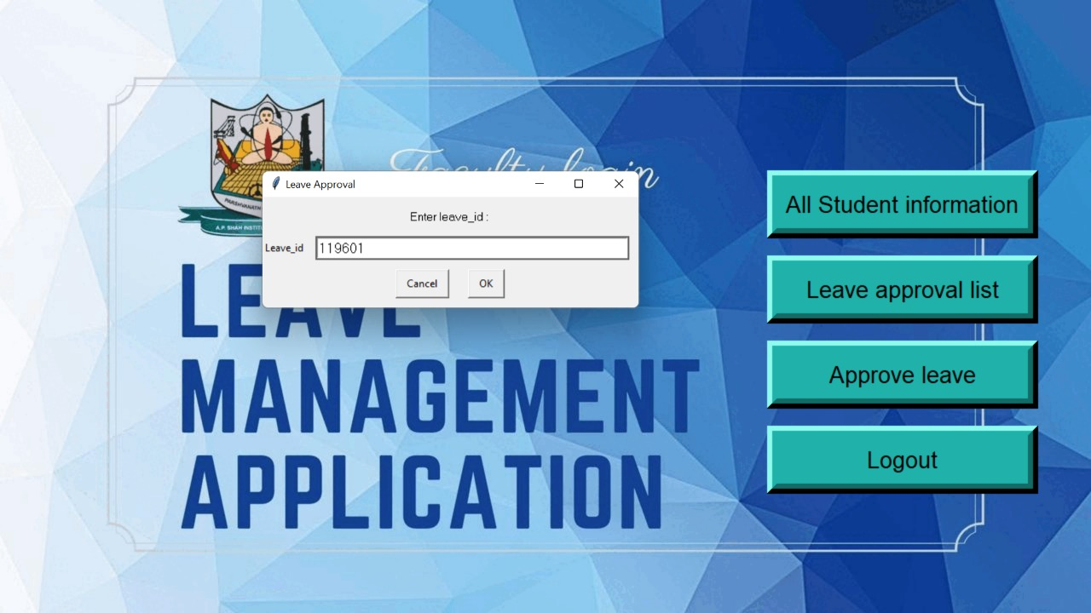

**FACULTY: DENY LEAVE**

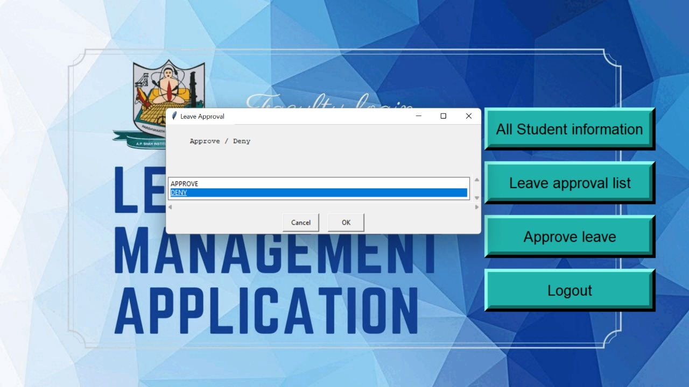

**Chapter 8**

**Project Scheduling Template**

|  |  |  |  |
| --- | --- | --- | --- |
| **Sr. No.** | **Group Member** | **Time duration** | **Work to be done** |
| 1  2 | Kunal Palande      Anish Bhosale | 1st week of January | Implementing 1st module (Designing main page of the portal which includes student registration, student login, faculty login and its database) |
| 2nd week of January | Testing 1st module (designing the student login portal that includes requesting leaves, view attendance, viewing student details and the database) |

|  |  |  |  |
| --- | --- | --- | --- |
| 3 | Shreya Mahajan | 3rd week of January | Implementing 2nd module (designing faculty login page where faculty can accept or deny leave requests, view student information and the database) |
| 4 | Saniya Dutta | By the end of march month | Implementing 3rd and 4th functionality (designing faculty login page where faculty can accept or deny leave requests, allow the requests only from the students who have 75% or more attendance and the database ) |

**Chapter 9**

**Conclusion**

Our leave management application is user friendly, intuitive and lets the faculty and the students coordinate properly regarding student's attendance and leaves. This Leave Management Application has all the requirements needed for maintaining student attendance and thus its very helpful to faculty members and students. It is a well-designed and minimalistic module to mitigate the tedious approach of maintaining records on paper.

**Chapter 10**

**References:**

* <https://youtu.be/rfscVS0vtbw>
* [Python - Functions (tutorialspoint.com)](https://www.tutorialspoint.com/python/python_functions.htm)
* [Python MySQL Create Database (w3schools.com)](https://www.w3schools.com/python/python_mysql_create_db.asp)

**Books:**

* Python Crash Course, 2nd Edition
* Head First Python
* Python Cookbook

**Chapter 11**

## ACKNOWLEDGEMENT

This project would not have come to fruition without the invaluable help of our guide **Prof. Susmita Das**. Expressing gratitude towards our HoD, **Prof. Kiran Deshpande**, and the Department of Information Technology for providing us with the opportunity as well as the support required to pursue this project. We would also like to thank our teacher **Ms. Anagha Aher** who gave us her valuable suggestions and ideas when we were in need of them. We would also like to thank our peers for their helpful suggestions.